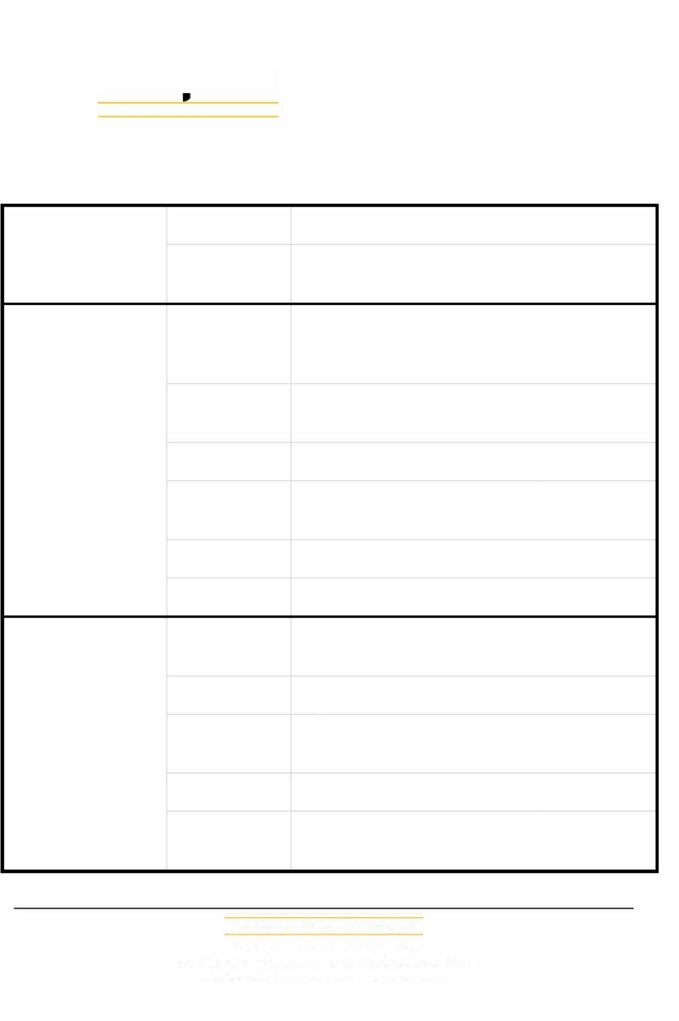

THE LOGISTICS NETWORK

WPA 13TH ANNUAL CONFERENCE AGENDA

Sunday
October 12th 2025

Monday
October 13th 2025

Coffee/tea breaks at 10:30 and 16:00

Tuesday
October 14th
2025

Coffee/tea breaks at 10:30 and 15:00
09:00 - 18:00

19:30 - 21:30

09:00 - 10:00

10:00 - 10:20

11:00 - 12:40

12:40 - 14:00

14:00 - 18:00

09:20- 10:00

10:00 - 12:40

12:40 - 14:00

14:00 – 16.00

17:00 – 22.00
Registration Desk open all day! Hotel Lobby

WPA Welcome Party (delegates and paid spouses)

Foyer Third Floor

Welcome Address by Peter van der Knaap, President of WPA: Overview of 2023-2024 / Review of Key Agenda items/ Award Ceremony / Ballroom 7th Floor

Group Photo will be taken Hotel Steps

Start of "One-on-One" meetings

Lunch (delegates and paid spouses) Hotel's Dining Rooms on 7th Floor

Continue "One-on-One" meetings Free Evening
Continue "One-on-One" meetings

Continue "One-on-One" meetings
Lunch (delegates and paid spouses) Hotel's Dining Rooms on 7th Floor

Continue "One-on-One" meetings

River cruise - dinner / music. Bus to venue depart at 17.00

Worldwide Partners Alliance, Ltd
Unit A 115, 1/F., Lee Ka Industrial Bldg,
No. 8 Ng Fong Street, San Po Kong• Kowloon, Hong Kong e-mail: admin@ourwpa.com• www.ourwpa.com

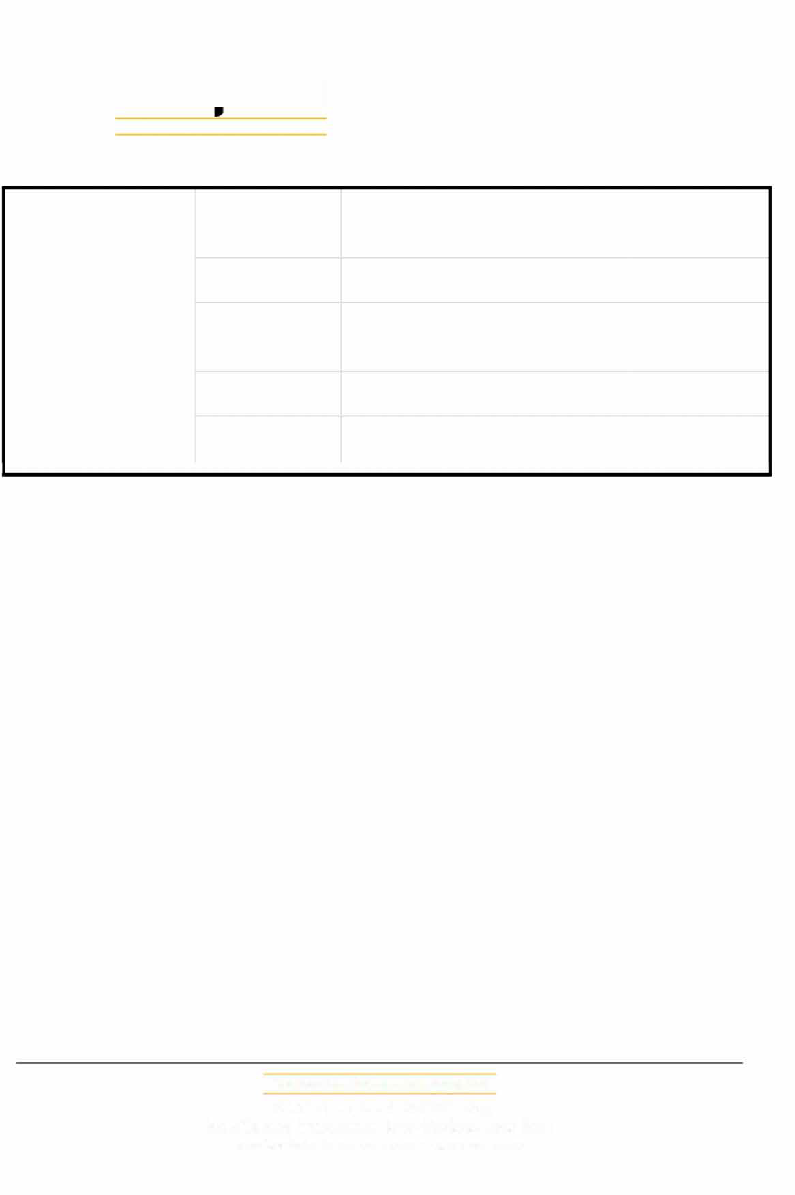
THE LOGISTICS NETWORK

Wednesday
October15th
2025

Coffee/tea breaks at 11:00 and 15:00

08:00 - 10:00

10:00 - 12:40

12:40 - 14:00

14:00 - 17:00

18:00 - 19:30
Informal Meetings to be scheduled by delegates themselves
Continue "One-on-One" meetings

Lunch (delegates and paid spouses) @ Hotel's Dining Rooms on 7th Floor

Continue "One-on-One" meetings

Good Bye Party – Foyer 3rd Floor

Worldwide Partners Alliance, Ltd
Unit A 115, 1/F., Lee Ka Industrial Bldg,
No. 8 Ng Fong Street, San Po Kong• Kowloon, Hong Kong e-mail: admin@ourwpa.com• www.ourwpa.com

